WEEK 2

AIMEN HASHMI

**university student portal using Figma**

## 

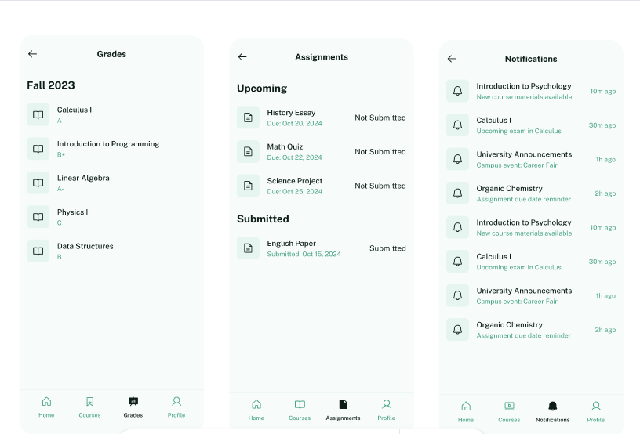

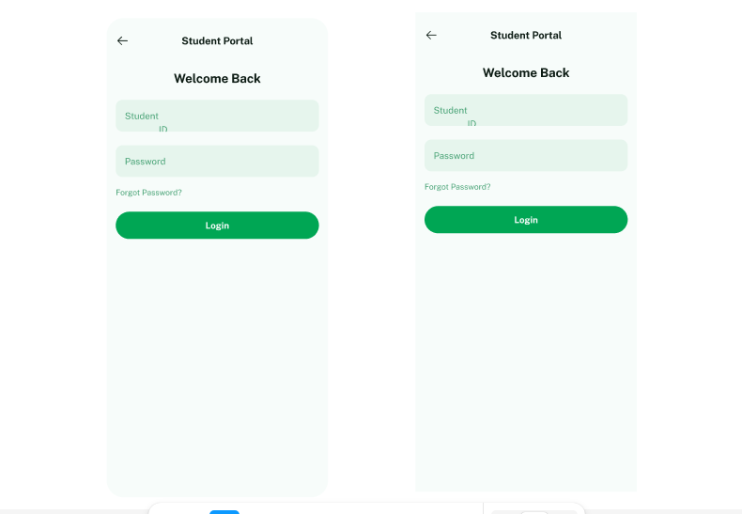

**END OF DOCUMENT**